**Name: Sanghavi Rangineni**

**Id:**

**Github:**

**Dataset link:** https://www.kaggle.com/datasets/mahmoudshogaa/us-crime-rates-1960-2014

**A Brief Overview of US Crime Trends in the 1960s**

In this report, we explore crime trends in the United States during the 1960s. Using a series of charts, we'll trace the patterns of various crimes through the decade. From the fluctuation of violent crimes to the specifics of the murder rate, and a detailed year snapshot, our visuals aim to provide a clear and concise understanding of this era's criminal landscape. Let's take a look at what the data can tell us about crime during a pivotal decade in American history.

1. **Crime Trends in the United States (Multiple Line Chart)**

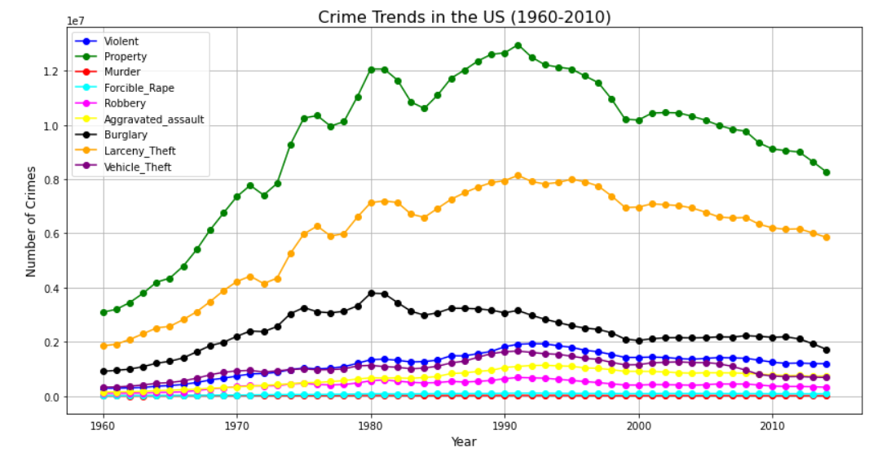

The multi-line chart gives us a big-picture view of crime trends in the US over 54 years. Each line shows a different type of crime, so we can compare them. The chart shows that violent crimes go up and down, with a scary spike in the early 1990s followed by a drop towards the end. Property crimes are more common, and they follow a similar trend, with a peak in the 1990s.This trend could be caused by bigger social and economic factors, like changes in how the police operate, the economy, and who lives where. The drop in crime rates in the 2000s might be due to advances in technology and security, better policing methods, and economic growth.

1. **Number of Murders in the United states - Bar graph**

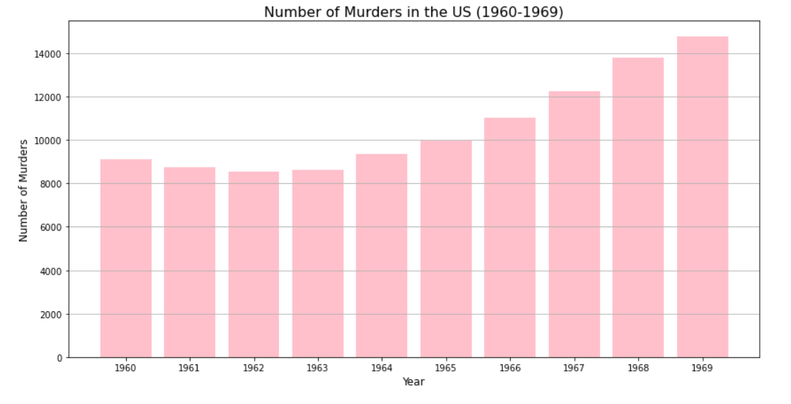

This bar chart shows the number of murders in the United States each year from 1960 to 1969. It's easy to see how the murder rate went up and down over the decade, with some years seeing big spikes. The data might be connected to the social unrest of the 1960s, including political assassinations, the civil rights movement, and cultural shifts. This chart is a sobering reminder of the dark side of the decade, and it focuses on one of the most serious types of crime.

1. **Pie Chart of Crime Distribution (1965)**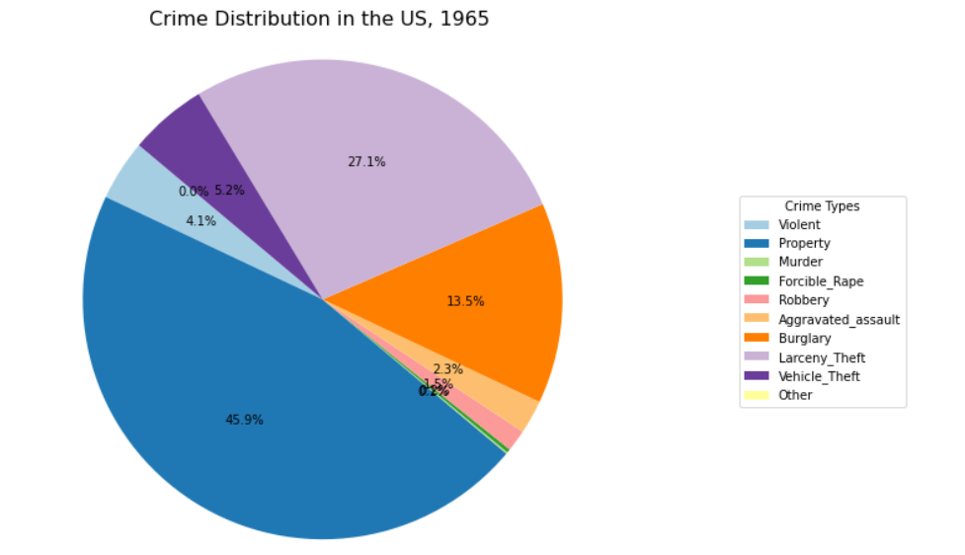

This pie chart shows what percentage of different types of crimes were committed in the United States in 1965. Property was the most common type of crime, followed by Larceny-theft, burglary, vehicle theft, and violent crimes like murder and aggravated assault. This distribution gives us a good idea of what the crime landscape looked like in the mid-1960s, and it could be useful for historical comparisons or making policy decisions about law enforcement and crime prevention

**Conclusion:**

The visualizations provide a thorough look at crime patterns in America during the 20th century. The line chart shows how different crimes zigged and zagged over the decades. Then that pie chart gave us a one-year snapshot of the crime flavor of the month. Don't forget that tubular bar graph zooming in on murder rates in the swinging '60s.Together, these charts let us dig into crime stats over time and compare categories. Studying crime with some historical context gives useful Intel that could help shape responses down the road. The visuals make the numbers talk and show connections that tables might hide.